Submerged Aquatic Vegetation in Cocktown Creek
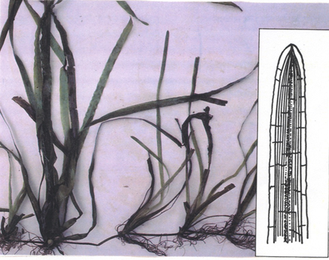

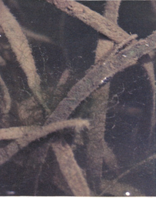
Wild Celery
Vallisneria americana
This SAV was once the most abundant species found in
Cocktown Creek. It was most common in the fall, although it was occasionally found growing in the Spring. The leaves are long and flattened like a shoelace. The plants have large root systems that are white in color. The plant is an important food source for ducks and provides shelter for many small fish, crabs, and shrimp.

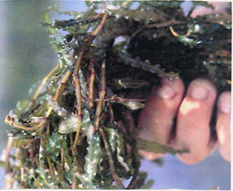
Curly Pondweed
Potamogeton crispus
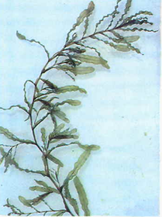
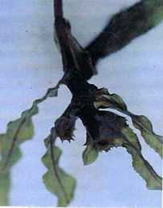
The leaves of the Curly Pondweed are curled along the edges. These plants are often found growing in large clusters. Although not an important food plant for wildlife, Curly Pondweed does provide a habitat for numerous aquatic creatures.

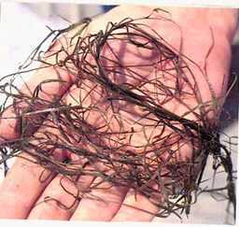
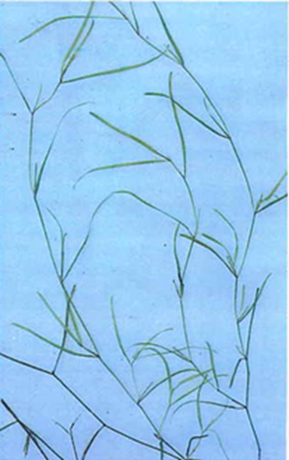

Slender Pondweed
Potamogeton pusillus
This plant has long, slender “grass-like” leaves that are arranged in pairs alternately along the stem. Slender Pondweed is found during Fall and Spring seasons in Cocktown Creek. The leaves and the seeds of this plant are eaten by waterfowl.
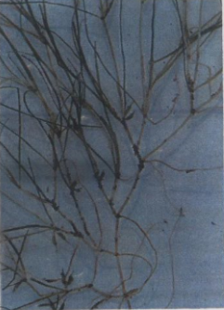
Horned Pondweed
Zannichellia palustris

This plant is very similar to Slender Pondweed. One important difference is that the Horned Pondweed has leaves that grow in clusters opposite one another along the stem. The Horned Pondweed has small “horn-like” seeds that grow between the leaves and the stem during the late Spring. This species is almost only found in the Spring. This plant is eaten by waterfowl.
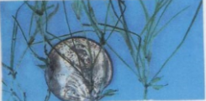

Common Waterweed
Elodea canadensis
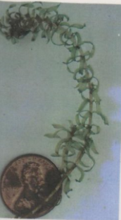
Look for small, flattened leaves with smooth edges. The leaves of this plant are arranged in groups of three around the stem and sometimes curl slightly. May be found during both the fall and spring seasons. This SAV species has little wildlife value as food, although it can provide shelter for small fish.
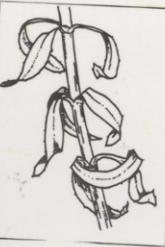

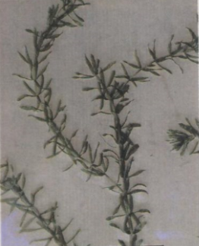
Hydrilla
Hydrilla verticillata

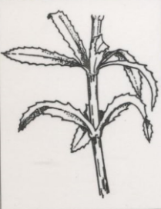
This species is very similar in appearance to Common Waterweed. The easiest way to identify Hydrilla is to look for the small leaves arranged in clusters of 5 leaves around the stem. Hydrilla leaves also have tiny “teeth” along the leaf edges however these can sometimes be difficult to see. Hydrilla is a problem species because it will form large mats that can be a nuisance to boaters. Hydrilla is an excellent food for waterfowl and forms a habitat for fish.
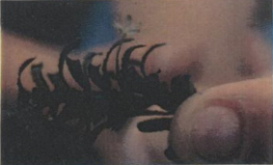

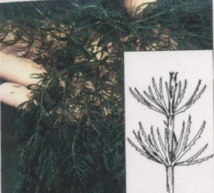
Coontail
Ceratophyllum demersum
This is a species that has no true roots and is often found floating in the creek. The plant has thin leaves that are arranged in clusters of ten or more around the stem.
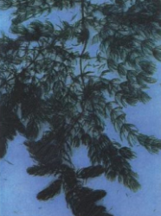
Each leaf has tiny teeth along one edge. The cluster of leaves are thicker toward the tip of the stems. This plant can be found during the Fall and Spring.
Although not eaten by many species of waterfowl, Coontail provides a great hiding place for many different plant species.

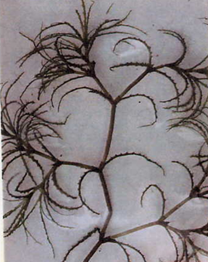
Naiad Species
Najas sp.
The Naiads are a group of SAV that prefer fresh-water environments. The SAV surveys at CHESPAX seem to indicate that these species become more common following a rainy summer or winter.
There are several different species of Naiads that may occur in Cocktown Creek. Since many of the species are very similar in appearance, we normally record these as “Naiad species”. The more common species in Cocktown Creek, Najas minor, has leave with tiny teeth on the edges. The leaves on this plant curve backward from the stem.

The leaves, stems and seeds of the Naiads are eaten by different species of waterfowl.

