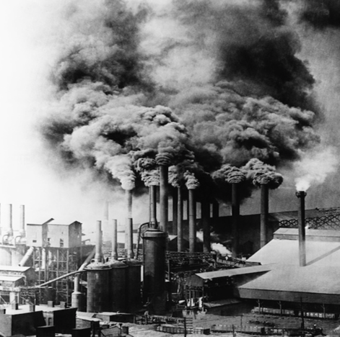
The Industrial Revolution and its Impact on the Environment

The Industrial Revolution was a period from the 18th to the 19th century where major changes in agriculture, manufacturing, mining, transport, and technology had a profound effect on the society, economy, and environment. Starting in the later part of the 18th century, there began a transition in parts of Great Britain’s previously manual labor and animal-based economy towards machine-based manufacturing. It started with the mechanization of the textiles industries, the development of iron-making techniques and the increased use of refined coal. The use of machinery and factories led to mass production, which in turn led to the development of numerous environmental hazards. The effects on the environment would only be seen clearly years later.

The industries that were set up during the industrial revolution used coal as the prime source of energy. Huge amounts of carbon particles were released into the atmosphere. The combination of smoke and fog produced smog, which was visible as a thick blanket over the cities. This caused deaths in thousands due to respiratory diseases. The Great Smog of London in 1952 killed more than 4000 people. Other noxious fumes were released as a byproduct of these industries, releasing dangerous gases that changed the chemistry of the air.

Although the Industrial Revolution boosted the economy it also harmed the environment at astronomical levels. With the race for industrialization and urbanization, both the developed and the developing countries began to exploit their natural resources especially coal, oil and gas, both to run the factories and their transport system, with little regard to the environment. The depletion of natural resources, the carbon emissions, pollution and human health problems that have resulted directly from the Industrial Revolution’s accomplishments have only been disastrous for the world environment.
Name _________________________________ Date __________ Period _________

