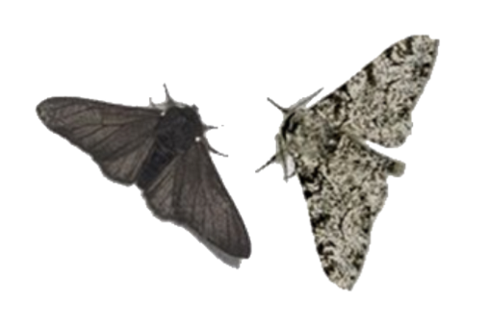
Peppered Moths

Peppered moths are normally white with black speckles across the wings, giving it its name. This pattern makes it well camouflaged against lichen-covered tree trunks when it rests on them during the day. There is also a naturally occurring genetic mutation which causes some moths to have almost black wings. These black forms (called melanic) are not well camouflaged on the lichen as the peppered forms and so that are more likely to be eaten by birds and other predators. This means that fewer black moths survive to breed and so they are less common in the population than the paler peppered forms.

In the nineteenth century it was noticed that in towns and cities the black moth was more common than the pale peppered moth. Industrialization and domestic coal fires had caused a sooty air pollution which killed off lichens and blackened urban tree trunks and walls. So now the pale peppered moth was more obvious to predators, while the melanic or black moth was better camouflaged and likely to survive and produce offspring. As a result, over successive generations, the black moths came to outnumber the pale forms in the towns and cities.

In the mid-twentieth century controls were introduced to reduce air pollution and as the air quality improved tree trunks became cleaner and lichen growth increased. Once again the pale peppered moths were camouflaged and the black moths were more noticeable. Natural selection has been seen to work in both direction, always favoring the moth that is best suited to the environmental conditions.

